机密★考试结束前
2025年云南省初中学业水平考试
英语
(全卷三个部分，共8页；满分70分，考试用时120分钟)
注意事项：
1.考生必须在答题卡上解题作答。答案应书写在答题卡的相应位置上，在试卷、草稿纸上作答无效。
2.考试结束后，请将试卷和答题卡一并交回。
第一部分 英语知识运用(共两节，满分20分)
第一节 单项填空(共10小题；每小题1分，满分10分)
从题中所给的A、B、C、D四个选项中选出能填入空白处的最佳选项。
1．—Is this Li Mei’s volleyball?
—Yes, it’s ________. Look, there is “LM” on it.
A．she B．her C．hers D．herself
2．—Linda, can you do housework?
—Yes, I________. I learned to cook at the age of eight.
A．must B．can C．should D．need
3．Most students in our school go home ________ bus on weekends.
A．in B．on C．at D．by
4．________ kind boy Mike is! He always helps his classmates with math.
A．How B．What C．What a D．What an
5．Fast food tastes delicious. ________ eating it too often is bad for your health.
A．Or B．And C．But D．So
6．Alice, you must wear a uniform because it builds school ________.
A．spirit B．chance C．peace D．knowledge
7．Journey to the West is one of ________ classic novels in China. People like reading it.
A．famous B．more famous C．the more famous D．the most famous
8．The film Ne Zha 2 is worth seeing. I ________ it three times so far.
A．have seen B．am going to see C．saw D．see
9．The 12th World Games ________ in Chengdu in August, 2025.
A．holds B．held C．is held D．will be held
10．—Tom, could you please tell me ________?
—Last month.
A．when did you join the basketball club B．when you joined the basketball club
C．why did you join the basketball club D．why you joined the basketball club
第二节 完形填空(共10小题；每小题1分，满分10分)
从题中所给的A、B、C、D四个选项中选出能填入空白处的最佳选项。
There was once a young man who always saw the bad side of things.
One day, he went on a trip to an island with his friend. Suddenly, a strong blew their boat far away. They called for help. But it would be at least a couple of hours anyone would find and help them. They had to in hot weather.
As they waited, the young man complained (抱怨) about the heat and the bad luck they were having.
When he reached for their water bottle, he said, “Oh no! The water bottle is half .” Then his friend looked at the bottle and said, “But it is half full too.” The young man watched his friend very . A smile slowly appeared on his face and of them laughed.
The young man thought to himself, “He is right. Being negative (消极的) doesn’t help.” He then his attitude (态度) gradually and started to see the good side of things.
Now the man is much older and has a happy family. He has become a person who sees the bottle half full, not half empty!
Happiness is never about having a smooth life—it’s about seeing the side in the dark moments. A sad person sees only problems, while a cheerful one looks for in problems. So next time when you are in a difficult situation, yourself, “Do I see a half-empty bottle, or a half-full one?” The choice is yours.
11．A．wind B．light C．sound D．rock
12．A．because B．since C．before D．after
13．A．cry B．wait C．swim D．run
14．A．clean B．dirty C．full D．empty
15．A．loudly B．seriously C．safely D．carelessly
16．A．both B．neither C．all D．none
17．A．stayed B．refused C．passed D．changed
18．A．strange B．bright C．scary D．boring
19．A．hobbies B．levels C．hope D．danger
20．A．ask B．help C．wish D．praise

第二部分 阅读理解(共三节，满分30分)
第一节(共5小题；每小题1.5分，满分7.5分)
根据短文内容，判断正误(正确“T”，错误“F”)。
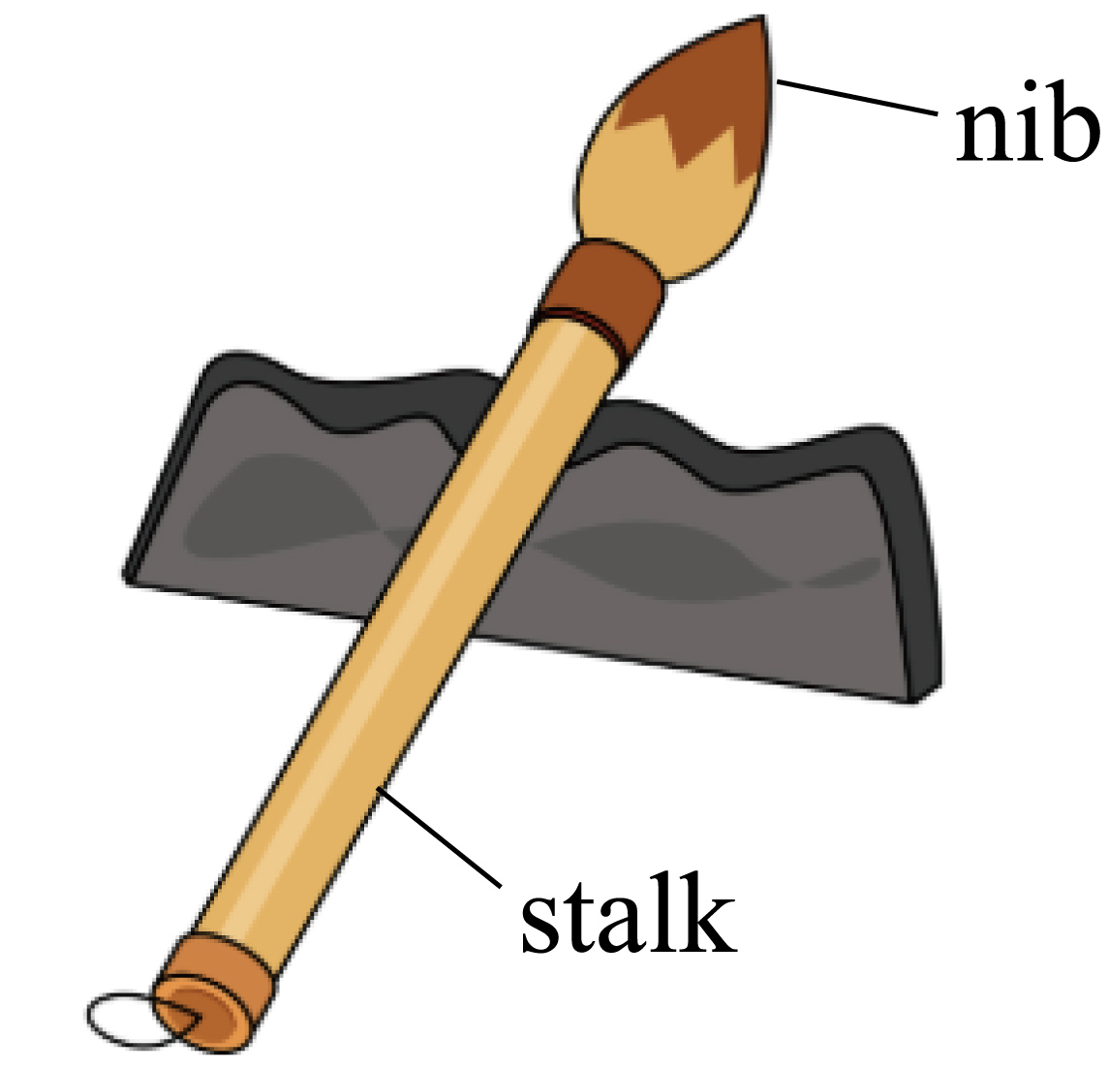
The ink brush is a traditional tool for writing and painting in ancient China. It’s also one of the “Four Treasures of the Chinese Study”. The earliest ink brush was found more than 2,500 years ago.
The Han Dynasty (202 BC—220 AD) is an important period for the development of the ink brush, and it is also the time when Cai Lun improved the paper-making method. People began to widely use ink brushes at that time. Meanwhile, the first book on how to produce ink brushes came out.
In the Yuan and Ming Dynasties, many ink brush experts got together in Huzhou of Zhejiang province and the brush-producing industry developed rapidly. Huzhou has been the center of brushing making since the Qing Dynasty. Ink brushes produced there, called the Hubi, are the best known.
The ink brush is made up of the stalk and the nib. The stalk is usually made of bamboo, wood or other valuable materials. The nib is made of fine, soft animal hair including three main kinds: rabbit’s hair, wool and weasel’s hair (黄鼠狼毛). People often call these nibs tuhao, yanghao, and langhao in Chinese.
The ink brush is made in three sizes: big, medium or small. Most works of calligraphy (书法) are written with a medium-sized brush. Usually, painters and calligraphers have several kinds of brushes on hand to meet personal purposes and preferences (喜好).
21．Ink brushes became popular in the Han Dynasty.
22．Huzhou has been the center of brushing making since the Yuan Dynasty.
23．The nib is made of good, soft animal hair including two main kinds.
24．Most works of calligraphy are created with a medium-sized brush.
25．The text mainly talks about a traditional tool—the ink brush.

第二节(共15小题；每小题1分，满分15分)
根据短文内容，从题中所给的A、B、C、D四个选项中选出最佳选项。
A

Enjoy DIY TimeBusy with your schoolwork on weekdays? Why not give yourself a chance to try something new? We have enough materials for you. Come and do your DIYs with the instructions below!
A Creme brulee (焦糖布蕾)
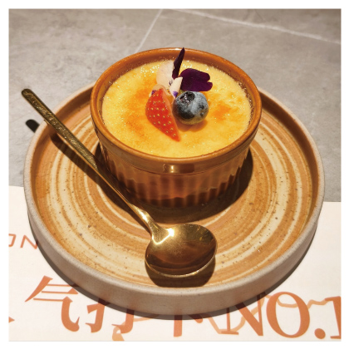•Mix egg yolks and sugar to make yolk liquid (蛋黄液).
•Mix light cream and milk with yolk liquid.
•Put the liquid in cups, cover the cups with tin foil (锡纸), and put them into the oven (烤箱), at a temperature of 160℃.
•Take the cups out of the oven and cool them down in the fridge.
•Put some sugar on them, then heat them until the sugar turns brown.
Time: 4:00 pm—4:30 pm on Monday Place: The dining hall Teacher: Miss Zhou
A Chinese kite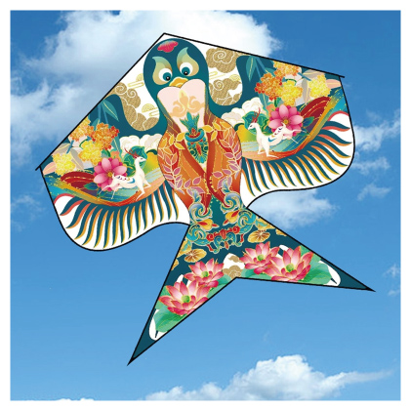•Fold the bamboo into the required shape and cut it into smaller strips (条).
•Use the bamboo strips to make a kite model you like.
•Stick the paper to the bamboo structure.
•Draw pictures on the paper.
•Fix all parts of the kite together.
•Check its structure and the length of the lines.
Time: 4:30 pm—5:30 pm on Friday Place: The art room Teacher: Mr. Li
26．What will students need to make a creme brulee according to the text?
a. Milk. b. Sugar. c. Bamboo. d. Egg yolks. e. Light cream. f. Lines.
A．a, b, c, e B．a, b, c, f C．a, b, d, e D．c, d, e, f
27．Which teacher can help Tom if he wants to make a creme brulee?
A．Miss Zhou. B．Mr. Li. C．Miss Zhao. D．Mr. Yang.
28．When is a Chinese kite DIY?
A．At 4:00 pm—4:30 pm on Monday. B．At 4:00 pm—4:30 pm on Friday.
C．At 4:30 pm—5:30 pm on Monday. D．At 4:30 pm—5:30 pm on Friday.
29．Which of the following is NOT true according to the text?
A．Students may spend an hour making a Chinese kite.
B．Students can follow five steps to make a creme brulee.
C．Students can do the two kinds of DIYs on the same day.
D．Students may use the bamboo strips to make a kite model they like.
30．What kind of text is this?
A．A story. B．A notice. C．A diary. D．A letter.

B
Wan Haibo, a 43-year-old deliveryman (快递员), was honored as a national model worker on April 28, 2025 in Beijing. He received this honor for his excellent delivery work and active volunteer work. Wan said, “I feel very excited and proud.”
Born in the countryside in Handan, Wan became a deliveryman in Tianjin in 2018. “It’s necessary to send every parcel (包裹) right to the customer in time,” he told the reporter from Beijing Daily. “The job is laborious, experiencing sunburn and wind. I thought about stopping, but finally got through the difficulties.”
Wan usually delivers 500 parcels per day (700 or even 1,000 parcels daily during some online shopping holidays or sales seasons). In the past seven years, he has delivered over 720,000 parcels without any mistake. He usually starts work around 6 am and finishes around 8 pm. Sometimes he has to work until midnight. When facing terrible weather and possible delivery delays (延迟), he will call the customer to explain the reasons.
Wan is a warm-hearted person who often pays much attention to the old and the disabled. He usually gets medicine for them and takes away their rubbish when delivering parcels.
Wan has also been a volunteer in his community since April 2022. As a volunteer, he helps to check the area’s sanitation conditions (卫生状况) and safety risks for the community.
Wan said, “I’m very pleased that we deliverymen have got more respect in recent years. I think I will continue to serve the delivery industry in the future and encourage more people around me to take part in volunteer work.”
31．What kind of honor did Wan Haibo get?
A．The most beautiful worker. B．A national model worker.
C．The best deliveryman. D．A moving deliveryman.
32．What does the underlined word “laborious” in paragraph 2 probably mean?
A．Hard. B．Easy. C．Interesting. D．Surprising.
33．How long has Wan Haibo been a volunteer in his community according to the text?
A．For about 8 years. B．For about 7 years.
C．For about 6 years. D．For about 3 years.
34．Which of the following words can best describe Wan Haibo according to the text?
A．Brave and lovely. B．Hard-working and warm-hearted.
C．Dishonest and impolite. D．Easy-going and well-dressed.
35．What can we learn from the text?
A．A deliveryman sends 1,700 parcels per day.
B．A deliveryman often calls the old for more advice.
C．A deliveryman usually helps the customers clean their rooms.
D．A deliveryman always does well in his delivery work and volunteer work.

C
Imagine that a cool bamboo-like grass can be used to make green energy. Scientists at Landuo Biotech, a business in Wuhan, have created one such plant recently. They name it “super giant reed” (超级芦竹).
Since 2012, the Landuo team have collected over 1,000 wild giant reeds for experiments. As a result, more than 40 varieties of super giant reed have been “born”. In the Landuo’s factory, hundreds of young reeds are grown in glass bottles. Fully grown, super giant reeds are cut and put in a special place without O₂. The Landuo team heat them up to make natural gas, which can then be used for energy.
Thanks to the scientists’ efforts, super giant reed has a biomass (生物量) three times that of wild giant reed. A kilogram of super giant reed also has 4,000 to 4,500 kilocalories (千卡) of energy. So, super giant reed is a great choice for taking the place of fossil fuels (化石燃料).
What’s more, growing super giant reed helps a lot. Planting 13,000 hectares of it can produce 0.45 to 1.5 million tons of fuel a year. 40 million hectares of super giant reed can be used instead of 2.2 billion (1 billion=1,000 million) tons of coal and can cut CO₂ emissions (排放) by 4 billion tons in China every year.
Super giant reed is also well-suited for growing on some land like beaches, wetlands and salty lands. Once a reed is planted, it can be cut and used many times during the next 15 to 20 years. By the end of 2024, over 3,300 hectares of super giant reed had been planted across 53 areas in China.
At present, China is developing this new energy source—super giant reed and we hope that it can help to make our planet cleaner and cleaner.
36．What is the right order according to paragraph 2?
a. The super giant reeds are cut by the Landuo team.
b. The super giant reeds are heated up to make natural gas.
c. The Landuo team grow lots of young super giant reeds in glass bottles.
d. The Landuo team put the super giant reeds in a special place without O₂.
A．a-b-c-d B．b-a-c-d C．c-b-d-a D．c-a-d-b
37．How many kilocalories of energy does a kilogram of super giant reed produce?
A．1,000 to 1,500. B．2,000 to 3,500.
C．4,000 to 4,500. D．5,000 to 5,500.
38．How does the writer support the main idea of paragraph 4?
A．By listing numbers. B．By telling stories.
C．By asking questions. D．By giving suggestions.
39．In which part of a newspaper can you probably read the text?
A．People. B．Science. C．Sports. D．Travel.
40．What can be the best title for the text?
A．Fossil Fuels B．CO₂ Emissions
C．Wild Giant Reed D．Super Giant Reed

第三节(共5小题；每小题1.5分，满分7.5分)
根据短文内容，从短文后所给的选项中选出能填入空白处的最佳选项。选项中有两项为多余选项。
Do you feel stressed (焦虑的) quite often? How do you deal with your stress? See a doctor? Perhaps you don’t need to do that if you can get into nature. 41
◆Match your daily routine (日常生活) to the sun.
42 Wake up when the sun rises and rest when it sets. Besides, try to be bathed in sunshine on sunny mornings—sunlight gives you energy for the day! When the sun sets, take breaks from your work.
◆ 43
Find somewhere green to enjoy your time. You don’t need a big forest! Any green place is all right—a garden, a park or even a tree near you. Spend 5 to 20 minutes relaxing or eating there every day.
◆Try “grounding” or “earthing”.
“Grounding” or “earthing” means “going touch grass”. There are healthy microbes (微生物) in the earth. 44 When you are at a picnic outdoors, take off your shoes and put your feet in the grass. (Be careful not to step on anything painful!)
◆Enjoy nature mindfully.
Nature gives people long-term happiness. 45 Walk into nature to watch the plants and wildlife. Or just close your eyes to feel the warmth of the sun on your skin. Breathe deeply and connect your mind with the beauty of nature.
A．Spend time in green places.
B．Go outdoors and keep working.
C．You can stay away from nature.
D．Live like a young plant following the sun.
E．Here are some simple ways from our experts.
F．These microbes are helpful to make your stress less.
G．You can put away your phone and enjoy nature with all your mind.

第三部分 写作(共三节，满分20分)
第一节(共5小题；每小题1分，满分5分)
根据句意，用括号中所给词的适当形式填空。
46．Every year, people celebrate World First Aid Day on the Saturday in September. (two)
47．She sang an English song for at the party yesterday. (we)
48．Our school trip was very . We all had fun. (wonder)
49．Teenagers are supposed to spend their money . (wise)
50．Nowadays, thousands of foreign come to China on vacation. (visit)
第二节(共5小题；每小题1分，满分5分)
将下列句子中汉语部分译成英语，注意使用适当的形式。
51．Young man, walk on and at the first crossing. You’ll see the bookstore. (向左转)
52．Kunming in Yunnan becomes a sea of flowers . (在春天)
53．Please don’t school. It’s a rule. (……迟到)
54．My family made a for my grandmother last Sunday. (生日蛋糕)
55．We will to stop water pollution near the lake tomorrow. (采取行动)
第三节 书面表达(满分10分)
56．你校校刊英语专栏正在开展以“An Unforgettable Class”为题的征文活动。请你用英语写一篇短文，向专栏投稿，叙述令你难忘的一节课，并谈谈你从中获得的感受或受到的启发。
要求：
1.根据所给题目，写一篇短文，词数不少于80；
2.语言流畅、书写规范、卷面整洁；
3.文中不得使用真实姓名、校名，否则以零分计；
4.请将短文写在答题卡上，写在本试卷上无效。
________________________________________________________________________________________________________________________________________________________________________________________________________________________________________________________________________________________________________________________________________________________________________________________________________________________________________________________________________________________________________________________________________________________________________________________________________________________

1．C
【详解】句意：——这是李梅的排球吗？——是的，是她的。看，上面有“LM”。
考查代词辨析。she她；her她；hers她的；herself她自己。由“Look, there is ‘LM’ on it”可知，此处指是李梅的排球，回答中使用名词性物主代词hers表示“她的排球”。故选C。
2．B
【详解】句意：——琳达，你会做家务吗？——是的，我会。我八岁时就学会做饭了。
考查情态动词。must必须；can能；should应该；need需要。根据“can you do housework”以及“I learned to cook at the age of eight”可知，应作肯定回答，表示会做家务，需用对应情态动词回答。故选B。
3．D
【详解】句意：我们学校的大多数学生周末乘公共汽车回家。
考查介词辨析。in在……里面；on在……上面；at在；by通过。by bus“乘公共汽车”，固定搭配。故选D。
4．C
【详解】句意：迈克是个多么善良的男孩啊！他总是帮助他的同学学习数学。
考查what引导的感叹句。由“…kind boy Mike is”可知，此处考查的是“What a/an+形容词+可数名词单数+主语+谓语！”句型，kind以辅音音素开头，故冠词用a。故选C。
5．C
【详解】句意：快餐尝起来很美味。但是吃得太多对你的健康有害。
考查并列连词辨析。Or否则；And和；But但是；So所以。由“Fast food tastes delicious”与“eating it too often is bad for your health”可知，前后句为转折关系，指的是虽然好吃，但吃太多不好。应用But连接。故选C。
6．A
【详解】句意：爱丽丝，你必须穿校服，因为它能树立学校精神。
考查名词辨析。spirit精神；chance机会；peace和平；knowledge知识。由“wear a uniform because it builds school”及常识可知，穿校服可以树立学校精神或建立集体荣誉感。故选A。
7．D
【详解】句意：《西游记》是中国最著名的经典小说之一。人们喜欢读它。
考查形容词最高级。“one of+the+形容词最高级+可数名词复数”表示“最……的……之一”，固定句型。故选D。
8．A
【详解】句意：电影《哪吒2》值得一看。到目前为止我已经看过三次了。
考查现在完成时。由“so far”可知，句子应用现在完成时。故选A。
9．D
【详解】句意：第十二届世界运动会将于2025年在成都举办。
考查一般将来时的被动语态。句子的主语是The 12th World Games，运动会是被举办的，所以要用被动语态，其结构是“be+过去分词”。句中的时间是2025年八月，时态是一般将来时，will be held是一般将来时的被动语态。故选D。
10．B
【详解】句意：——汤姆，你能告诉我你什么时候加入篮球俱乐部的吗？——上个月。
考查宾语从句及其语序。由“Last month”可知，此处应用when引导宾语从句，排除C和D；宾语从句从句需用陈述语序。故选B。

11．A 12．C 13．B 14．D 15．B 16．A 17．D 18．B 19．C 20．A
【导语】本文讲述了总是消极看待事物的年轻人在旅行遇险时，受朋友启发改变态度，最终明白幸福在于在困境中看到光明面的道理。
11．句意：突然，一阵强风把他们的船吹得很远。
wind风；light光；sound声音；rock岩石。由“a strong…blew their boat far away”可知，是强风把船吹远了。故选A。
12．句意：但至少要过几个小时才会有人发现并帮助他们。
because因为；since自从；before在……之前；after在……之后。“It would be+时间段+before…”为固定句型，表示“过多久才……”，此处指过几小时才有人来救援。故选C。
13．句意：他们不得不在炎热的天气里等待。
cry哭泣；wait等待；swim游泳；run奔跑。由“But it would be at least a couple of hours before anyone would find and help them”可知，前文提到他们呼救后需要时间等待救援。故选B。
14．句意：当他伸手去拿他们的水瓶时，他说：“哦，不！水瓶已经空了一半。”
clean干净的；dirty脏的；full满的；empty空的。由“‘But it is half full too’”可知，年轻人认为水瓶已经空了一半了。故选D。
15．句意：年轻人非常严肃地看着他的朋友。
loudly大声地；seriously严肃地；safely安全地；carelessly粗心地。由“Then his friend looked at the bottle and said, ‘But it is half full too.’ The young man watched his friend very…”可知，年轻人对朋友的不同观点感到严肃。故选B。
16．句意：他的脸上慢慢露出笑容，两人都笑了起来。
both两者都；neither两者都不；all三者及以上都；none三者及以上都不。此处指年轻人和朋友两人都笑了。故选A。
17．句意：他随后逐渐改变了自己的态度，开始看到事物的积极面。
stayed保持；refused拒绝；passed经过；changed改变。由后文“started to see the good side”可知，他改变了消极态度。故选D。
18．句意：幸福从来不是拥有一帆风顺的生活，而是在黑暗时刻看到光明的一面。
strange奇怪的；bright光明的；scary可怕的；boring无聊的。由“it’s about seeing the…side in the dark moments”可知，是在黑暗时刻看到光明的一面。故选B。
19． 句意：悲伤的人只看到问题，而快乐的人却在问题中寻找希望。
hobbies爱好；levels水平；hope希望；danger危险。由“while a cheerful one looks for…in problems”可知，积极的人是在问题中寻找希望。故选C。
20．句意：所以下次当你处于困境时，问问自己：“我看到的是一个半空的瓶子，还是一个半满的瓶子？”
ask问；help帮助；wish希望；praise表扬。由“‘Do I see a half-empty bottle, or a half-full one’”可知，是问自己。故选A。
21．T 22．F 23．F 24．T 25．T
【导语】本文主要是介绍中国传统的书写和绘画工具——毛笔。
21．细节理解题。根据“The Han Dynasty (202 BC—220 AD) is an important period for the development of the ink brush, and it is also the time when Cai Lun improved the paper-making method. People began to widely use ink brushes at that time”可知汉代是毛笔发展的重要时期，也是蔡伦改进造纸方法的时期，那时人们开始广泛使用毛笔，所以毛笔在汉代开始流行，故填T。
22．细节理解题。根据“Huzhou has been the center of brushing making since the Qing Dynasty.”可知湖州自清代以来一直是制笔中心，而不是元代，故填F。
23．细节理解题。根据“The nib is made of fine, soft animal hair including three main kinds: rabbit’s hair, wool and weasel’s hair”可知笔尖是由优良柔软的动物毛发制成的，主要有三种：兔毛、羊毛和黄鼠狼毛，而不是两种，故填F。
24．细节理解题。根据“Most works of calligraphy (书法) are written with a medium-sized brush.”可知大多数书法作品都是用中等大小的毛笔书写的，故填T。
25．主旨大意题。本文主要是介绍中国传统的书写和绘画工具——毛笔，故填T。
26．C 27．A 28．D 29．C 30．B
【导语】本文主要介绍了两项 DIY 活动的相关信息，包括焦糖布蕾和中国风筝的制作材料、步骤、时间、地点及指导老师等内容。
26．细节理解题。根据“•Mix egg yolks and sugar to make yolk liquid (蛋黄液).”和“•Mix light cream and milk with yolk liquid.”可知，制作焦糖布蕾需要egg yolks、sugar、light cream和milk。故选C。
27．细节理解题。根据“Teacher: Miss Zhou”可知，Miss Zhou是该活动的指导老师。故选A。
28．细节理解题。根据“Time: 4:30 pm—5:30 pm on Friday”可知，中国风筝DIY的时间是星期五下午4点半到5点半。故选D。
29．细节理解题。根据“Time: 4:00 pm—4:30 pm on Monday”和“Time: 4:30 pm—5:30 pm on Friday”可知，两个活动的时间不在同一天。故选C。
30．推理判断题。细读文章可知，文章以通知的形式罗列活动信息，包括标题、活动内容、步骤、时间、地点等，符合通知的格式特征。故选B。
31．B 32．A 33．D 34．B 35．D
【导语】本文主要讲述了快递员万海波因其出色的快递工作和积极的志愿活动被授予全国劳动模范称号，他不仅在工作中克服困难、高效完成任务，还热心帮助他人并积极参与社区志愿服务。
31．细节理解题。根据“Wan Haibo, a 43-year-old deliveryman (快递员), was honored as a national model worker on April 28,2025 in Beijing”可知，万海波被授予全国劳动模范称号，故选B。
32．词义猜测题。根据“The job is laborious, experiencing sunburn and wind. I thought about stopping, but finally got through the difficulties”可知，这份工作要经历风吹日晒，想过放弃，但最终克服了困难，所以这份工作是辛苦的，laborious意思是“辛苦的”，与Hard意思相近，故选A。
33．细节理解题。根据“Wan has also been a volunteer in his community since April 2022”可知，万海波从2022年4月开始在社区做志愿者，到现在大约3年了，故选D。
34．推理判断题。根据“In the past seven years, he has delivered over 720,000 parcels without any mistake”可知在过去的七年里，他已经毫无差错地递送了72万多个包裹，可见他工作努力认真；根据“Wan is a warm-hearted person who often pays much attention to the old and the disabled”可知他热心帮助老人和残疾人，所以他是勤奋和热心的，故选B。
35．推理判断题。根据“He received this honor for his excellent delivery work and active volunteer work.”以及全文内容可知，本文主要介绍了全国劳动模范万海波的优秀事迹，他不仅快递工作出色，而且积极做志愿者工作，故选D。
36．D 37．C 38．A 39．B 40．D
【导语】本文主要是介绍科学家们创造了一种新的植物——超级芦竹，它可以用来制造绿色能源。
36．细节理解题。根据“In the Landuo’s factory, hundreds of young reeds are grown in glass bottles. Fully grown, super giant reeds are cut and put in a special place without O₂. The Landuo team heat them up to make natural gas, which can then be used for energy.”可知，在蓝朵的工厂里，数百株幼芦竹被种植在玻璃瓶中。完全成熟后，超级芦竹被切割并放置在一个没有氧气的特殊地方。蓝朵团队将它们加热制成天然气，然后可以用作能源。所以正确的顺序是c-a-d-b，故选D。
37． 细节理解题。根据“A kilogram of super giant reed also has 4,000 to 4,500 kilocalories (千卡) of energy”可知，一公斤超级芦竹有4000到4500千卡的能量。故选C。
38．推理判断题。根据“Planting 13,000 hectares of it can produce 0.45 to 1.5 million tons of fuel a year. 40 million hectares of super giant reed can be used instead of 2.2 billion (1 billion=1,000 million) tons of coal and can cut CO2 emissions (排放) by 4 billion tons in China every year”可知，种植1.3万公顷的超级芦竹每年可生产45万至150万吨燃料，4000万公顷的超级芦竹可以替代22亿吨煤炭，每年可减少中国40亿吨的二氧化碳排放，所以作者是通过列举数字来支持第四段的主要观点的，故选A。
39．推理判断题。本文主要是介绍科学家们创造了一种新的植物——超级芦竹，它可以用来制造绿色能源，属于科学范畴，故选B。
40．最佳标题题。本文主要是介绍科学家们创造了一种新的植物——超级芦竹，它可以用来制造绿色能源，所以选项D“超级芦竹”符合，故选D。
41．E 42．D 43．A 44．F 45．G
【导语】本文介绍了一些简单的方法，帮助人们通过亲近自然来缓解压力。
41．根据“How do you deal with your stress? See a doctor? Perhaps you don’t need to do that if you can get into nature”以及下文可知，此处是引出下文缓解压力的方法，选项E“这是我们专家给出的一些简单方法”符合语境，故选E。
42．根据“Match your daily routine (日常生活) to the sun.”以及“Wake up when the sun rises and rest when it sets”可知，此处说的是要像植物一样跟随太阳，选项D“像追随太阳的幼苗一样生活”符合语境，故选D。
43． 根据“Find somewhere green to enjoy your time”可知，此处说的是要待在绿色的地方，选项A“花时间在绿色的地方”符合语境，故选A。
44．根据“There are healthy microbes (微生物) in the earth”以及“When you are at a picnic outdoors, take off your shoes and put your feet in the grass.”可知，此处说的是地球上的微生物对人的好处，选项F“这些微生物有助于减轻你的压力”符合语境，故选F。
45．根据“Nature gives people long-term happiness”以及“Walk into nature to watch the plants and wildlife”可知，此处说的是要全身心投入大自然，选项G“你可以放下手机，全心全意地享受大自然”符合语境，故选G。
46．second
【详解】句意：每年9月的第二个星期六，人们都会庆祝世界急救日。此处指“第二个星期六”，表示顺序用序数词second“第二”。故填second。
47．us
【详解】句意：昨天在聚会上，她为我们唱了一首英文歌。此处作介词for的宾语用代词宾格us“我们”。故填us。
48．wonderful
【详解】句意：我们的学校旅行非常精彩。我们都玩得很开心。此处作be动词的表语用形容词wonderful“精彩的”。故填wonderful。
49．wisely
【详解】句意：青少年应该明智地花钱。此处修饰动词spend用副词wisely“明智地”。故填wisely。
50．visitors
【详解】句意：如今，成千上万的外国游客来中国度假。根据“come to China on vacation”可知是游客来中国度假，visitor“游客”，thousands of后加可数名词复数。故填visitors。
51．turn left
【详解】句意：年轻人，往前走，在第一个十字路口向左拐。你会看到书店。向左转：turn left，固定搭配；由“walk on and…”可知，此处应用动词原形。故填turn left。
52．in spring
【详解】句意：云南的昆明在春天变成了花的海洋。在春天：in spring，固定用法。故填in spring。
53．be late for
【详解】句意：请上学不要迟到。这是一条规则。be late for“迟到”，助动词don’t后加动词原形。故填be late for。
54．birthday cake
【详解】句意：上星期天，我的家人为我奶奶做了一个生日蛋糕。生日蛋糕：birthday cake；由“a”可知，应用可数名词单数。故填 birthday cake。
55．take action
【详解】句意：明天我们将采取行动阻止湖附近的水污染。采取行动：take action，will后加动词原形。故填take action。
56．例文
An Unforgettable Class
Last Friday, we had an unforgettable English class. Our teacher, Mr. Wang, started the class with a fun game called “Guess the Word”. We were divided into two teams and had to guess English words from our teammates’ drawings. Everyone was excited and laughed a lot. After the game, Mr. Wang taught us some new words. He used interesting stories to help us remember them. I learned many new words easily.
This class was so interesting that I didn’t want it to end. I realized that learning English can be fun and exciting.
【详解】[总体分析]
①题材：本文是一篇话题作文；
②时态：时态为一般过去时；
③提示：本文主要是介绍令你难忘的一节课，适当增加细节，突出写作重点。
[写作步骤]
第一步，详细叙述令你难忘的一节课；
第二步，谈谈你从中获得的感受。
[亮点词汇]
①be divided into被分成
②use sth. to do sth.使用某物做某事
[高分句型]
①This class was so interesting that I didn’t want it to end. (so...that引导的结果状语从句)
②I realized that learning English can be fun and exciting. (that引导的宾语从句)

